RESEARCH RESULTS – Final Report August, 2012

Title: Fostering complex soil food webs and building soil fertility with organic production: the potential of perennial wheat

Investigators: Sieg Snapp, Professor, and Steve Culman, Post doc., Department of Plant and Soil Microbial Sciences, Michigan State University; Vicki Morrone, Organic farming specialist, Center for Regional Food Systems, Michigan State University
Collaborators: Tianna Dupont, Nematologist Penn State Univ; John Edgerton, Farmer; Martin Nagelkirk, Extension educator; Lee and Linda Prudy, Westwind Milling and farmers; Christine Sprunger, Student MSU; Howard Straub, Farmer

Locations: Central and Southwest Michigan

Links: Print version of project summary (pdf)
Complete Project report submitted by Sieg Snapp (pdf)
Check out the perennial grain website: http://pwheat.anr.msu.edu/

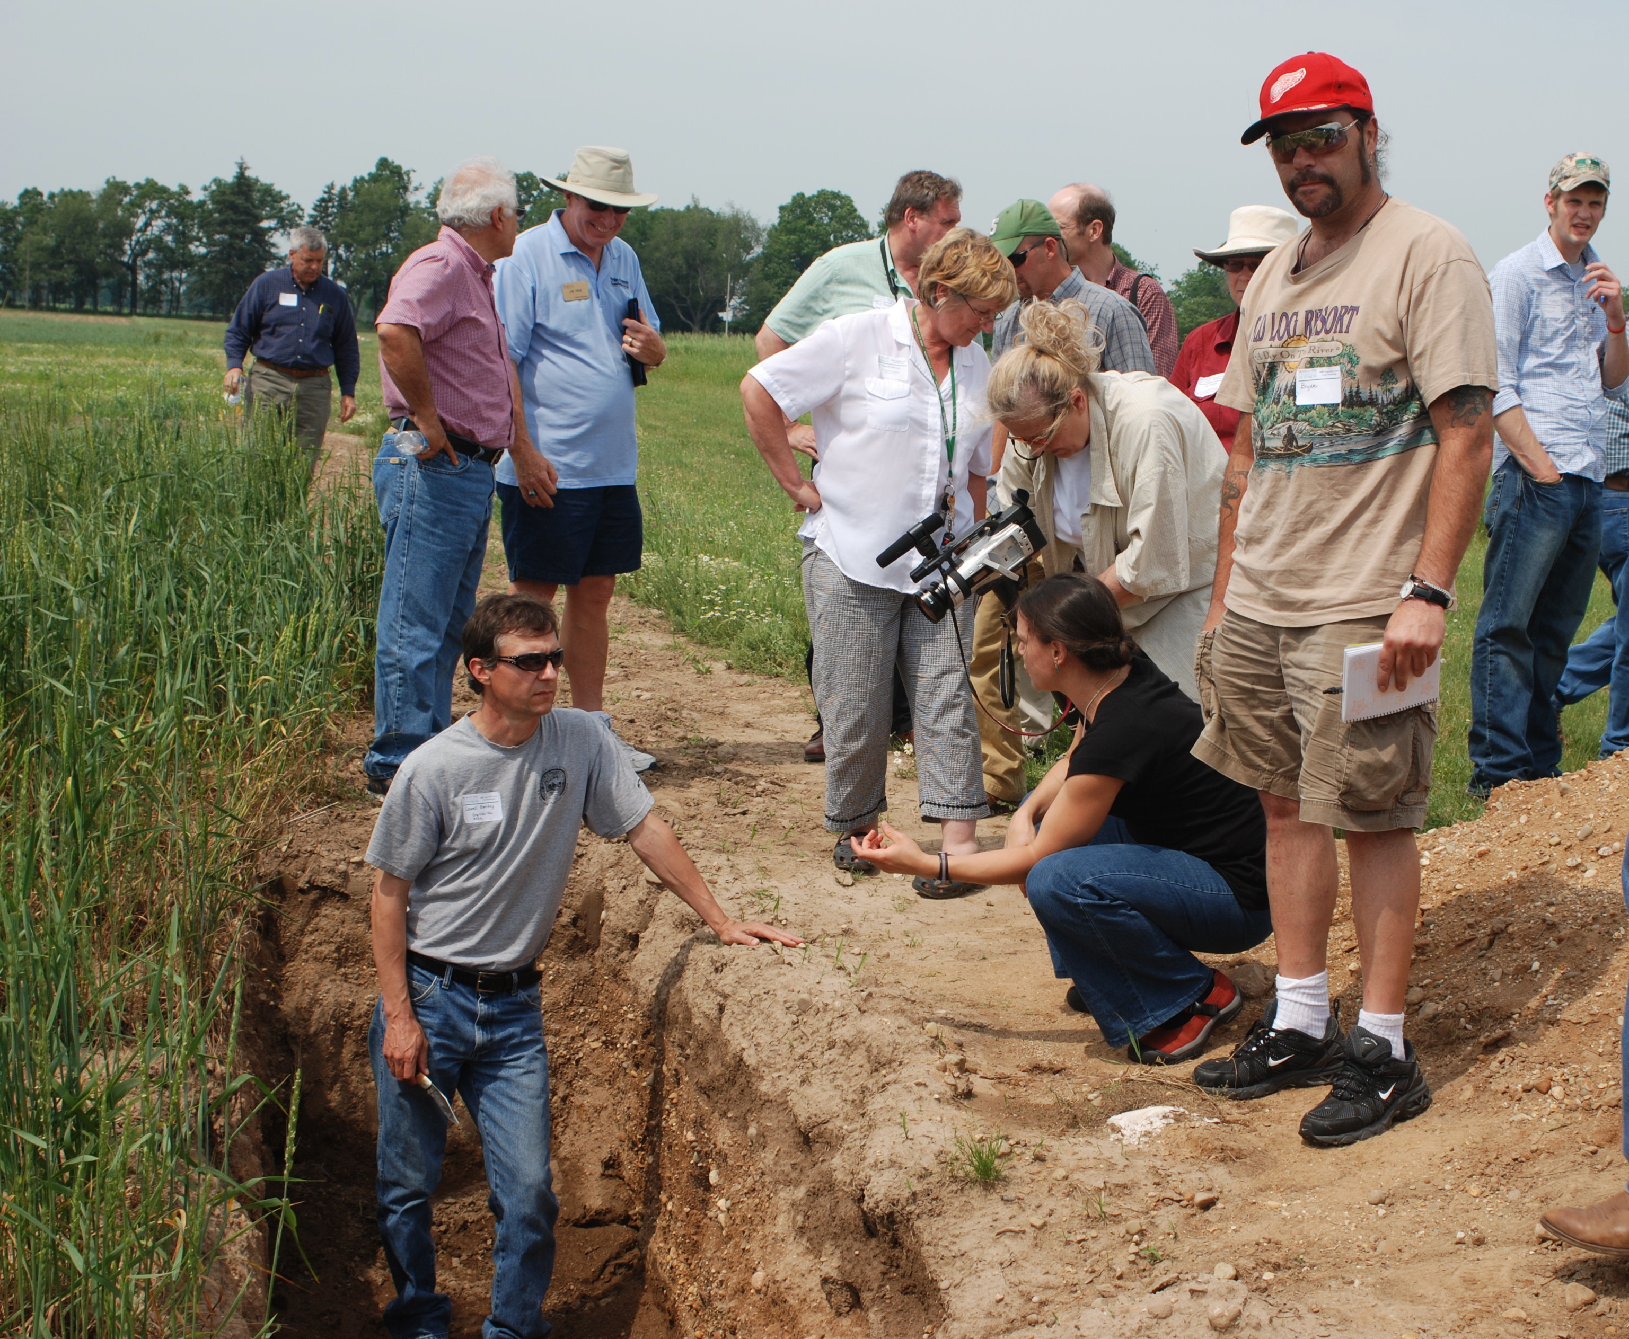
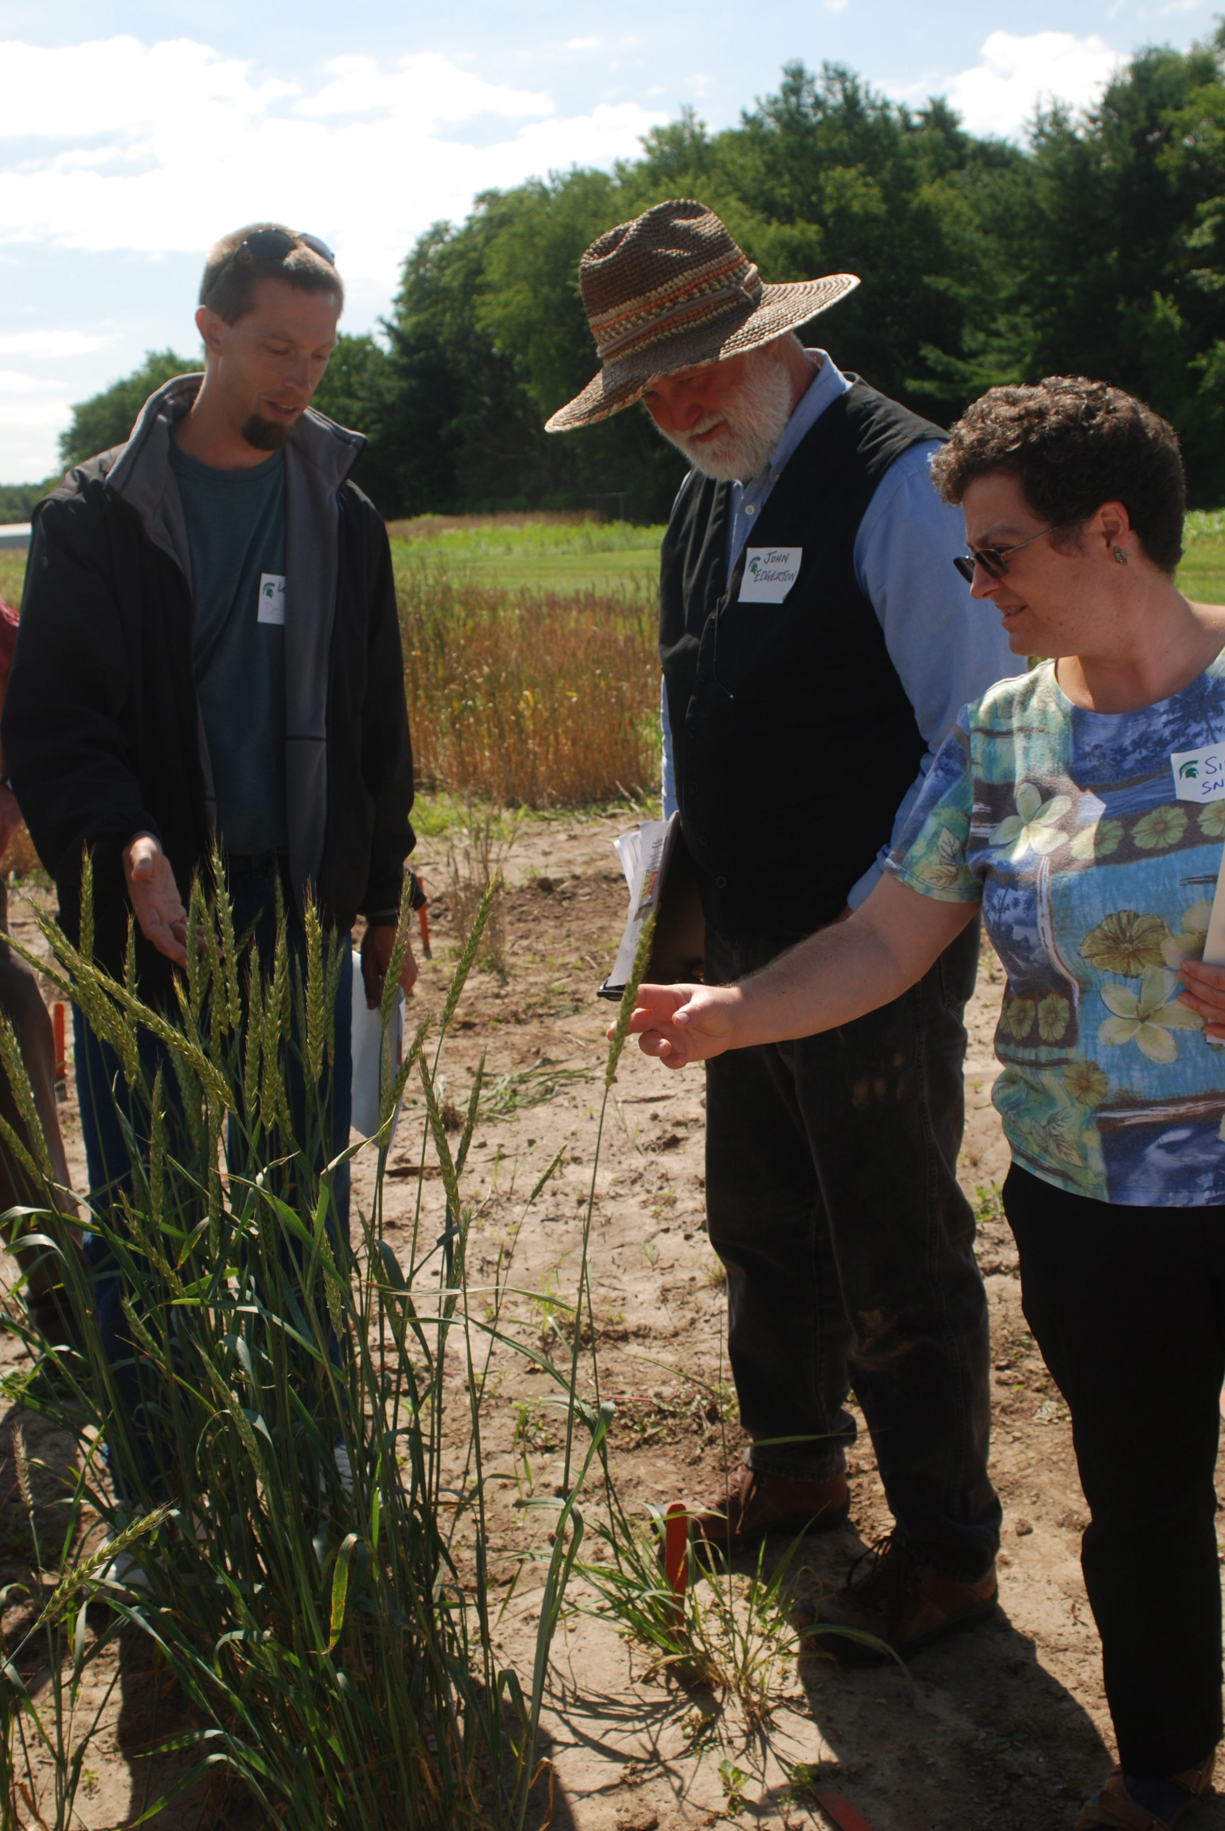

W.K. Kellogg Biological Station field days - evaluating perennial grains roots and all.

Organic farmers are looking for new ways to grow crops, and novel market opportunities afforded by new crops. Perennial cereals such as intermediate wheatgrass (Kernza) and perennial wheat have sparked a great deal of interest among organic growers who are interested in dual purpose crops that can be grazed in the spring and harvested for grain in the summer. The perennial nature of these crops - and the extensive rooting systems - will likely have outstanding benefits for soil organic matter and soil biota. Perennial grains could be an invaluable tool for organic farmers in the future, given the potential to support complex soil food webs, overall greater access to soil nutrients and soil water and thus superior ability to suppress weeds and build healthy soils.

This project is using minirhizotrons as windows belowground (see images below) and deep soil sampling to examine the roots and soil biology associated with a long-term project to develop perennial cereals for organic farmers in the upper Midwest. The most promising lines of the newly developed cereals intermediate wheatgrass and perennial wheat are being evaluated under organic and nitrogen fertilizer management at the W.K. Kellogg Biological Station in southwest Michigan. Also, we have added an observational site in central Michigan at the Mason Wheat Research farm, Michigan State University. Soil biological measurements include: respiration, enzymes, nematode communities, soil organic matter fractions and total soil carbon, and mycorrhizal fungi.

Objective 1. Determine key differences in soil microbial and nematode communities between organic annual wheat and organic perennial wheat.

Two long-term field trials were planted at the Farming Systems Center at Kellogg Biological Station in November 2009. One trial is evaluating soil biology under organic management, and conventional-produced wheat and a new perennial grain crop, wheatgrass ‘Kernza’. The other trial is investigating ‘dual use’ of perennial wheat and Kernza as producers of forage and grain yield, as well as environmental benefits from superior water quality and soil health. See appendix I for our preliminary findings on yield, research supported largely by complementary funding from USDA OREI.

Perennial wheat lines were developed by small grain breeders at Washington State University (Dr. Steve Jones and Dr. Kevin Murphy). Intermediate wheatgrass is being developed as a new grain by Dr. Lee DeHann at The Land Institute in Kansas. We appreciate Dr DeHann sharing improved lines of IWG. The IWG species is a perennial grass relative of annual wheat, and is the plant that has been used as a perennial source for developing perennial wheat, through crosses between IEG and annual wheat. Intermediate wheatgrass is currently being domesticated as a perennial grain crop, but the yields are still low to moderate, 300 to 1600 lb per acre. To sum up, IWG is a vigorous, true perennial grass that will likely act more as a forage crop, with some modest grain yields. Intermediate wheatgrass could fit well into organic dairy operations or into integrated grazing systems.

Plant establishment in the first spring was respectable, despite a very late planting due to an extremely wet fall, and the IWG regrew very well in the fall of 2010, then established vigorous regrowing plants in 2011 and 2012. Plants were monitored and physiological data recorded each spring. Soil was sampled at the beginning of the experiment, and ten times subsequently. We sampled annual and IWG (also called Kernza) under all of the management practices. Soil cores were taken to 1 meter depth – see photo below - and divided into 5 intervals to measure soil biology at different depths (0 – 10 cm, 10 – 20 cm, 20 – 40cm, 40 – 70 cm, 70 – 100 cm).

The analyses run on these soils include:
- Chemically-labile organic matter and CO2 respiration (labile carbon pool)
- Potentially mineralizable nitrogen (labile, rapidly cycled nitrogen pool)
- Inorganic nitrogen (nitrate/ ammonium; plant-available nitrogen)
- Soil enzyme analysis. Seven separate enzyme activities analyzed to quantify relative rates of organic matter decomposition and nutrient cycling
- Nematode communities extracted and microscopically identified to the family or genus level; soil food web indices calculated based on the communities

In addition to crop grain and forage biomass, and the above soil analyses, other data is being collected throughout the year to assess water quality. Every two weeks, soil moisture is measured at four individual depths and soil water leached below the rooting zone is collected (via suction lysimeters). All data are statistically analyzed, to evaluate the impact of organic management, and the plant type, annual versus perennial wheat, and intermediate wheatgrass. Initial findings have been summarized to report to farmers at the June 27, 2012 field day and written up in a paper submitted to the Agronomy Journal (see publications below). Specific soil biological parameters such as nematode community structure was not very responsive in 2010 or 2011, but we sampled again in 2012 and look forward to analyzing the results.

As we continue this long-term experiment, the results will allow us to quantify the environmental benefits over time – such as improved soil biology, water quality and reduced leaching of nitrogen. We expect some benefits to be associated with organic management, some with growing a perennial grain, and most of all with the combination of organic management and a perennial grain. Soil biology as reflected in respiration measurements (see below) and enzymes are already showing marked responses. The organic treatment is on the right top side of the graph and the Kernza perennial grain respiration is shown in blue. Initial findings for soil respiration – a measure of the soil biology activity – indicate that soil biology was active in organic managed soils, at the top of the soil profile (see 0-10 cm). This was the case for both annual wheat and IWG (Kernza), as shown in the figure. In general, Kernza was also more biologically active.

Research findings on nutrient cycling are very promising: water quality was 95 to 100% pure (no detectable nitrogen leaching for most of the growing season) in the perennial grain Kernza (Culman et al., ms submitted to Agronomy Journal). Nitrogen management in crops through understanding biology is an ongoing area of interest in our group, and we have collaborated with soil scientist Dr Stuart Grandy on a chapter addressing this (see publications list below).

Objective 2. Assess the role of perenniality in shaping soil food web complexity and nutrient cycling in organically managed wheat

Perennial grain effects on soil food webs, shown through monitoring roots, enzymes and nematode communities, are starting to be observed. Root findings are being reported by Christine Sprunger at two science meetings in fall of 2012, and we have proposed a panel with farmers at MOSES in the spring of 2013. A soil biology research paper has been outlined by Steve Culman and Sieg Snapp, and will be submitted for publication soon. Root measurements are being conducted through deep soil sampling for measuring biomass, and non-destructive to evaluate turnover of roots through a minirhizotron (miniature camera inserted through transparent tubing installed deep into the soil). This is providing crucial new information on how deep roots grow and influence the ‘rhizosphere’ around the root. Roots are important to measure as they act as both the primary food source and habitat for soil microorganisms. Below are root measurement technique images and initial data images (C. Sprunger, unpublished data from her PhD).
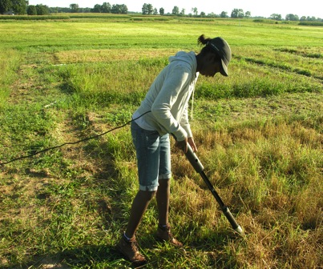
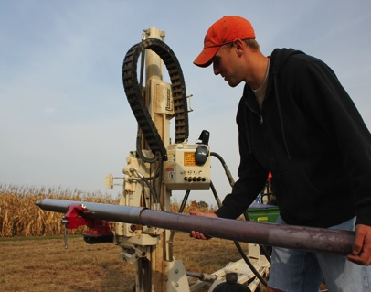
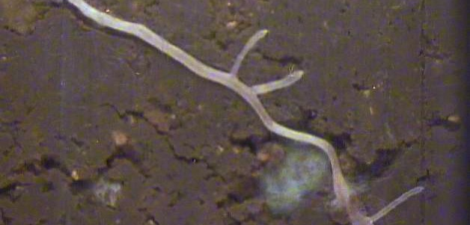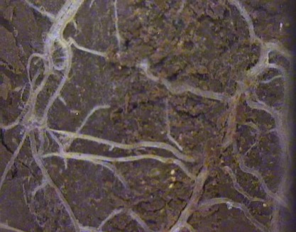
Annual wheat - nitrogen fertilizer
IWG (Kernza) - organic management

Forage/dual use experiment. In the second field experiment we are evaluating perennial wheat and IWG as dual use crops, for forage and grain. This allows quantification of how establishment and perenniality of the crop is influenced by management, including time of cutting and establishment. The graduate student Sienna Tinsley who is working on this has been provided support by a Ceres Foundation graduate student grant and she is working full time on this experiment. Initial results have been summarized in a fact sheet, see below and were presented to farmers on June 27, 2012 at the KBS field day.

Objective 3. Promote experiential learning about soil biology among organic farmers.

We are pursuing a farmer participatory research model, including three field days held at the Kellogg Biological Station and June 27th, 2012 we held a farmer assessment day, where perennial grain lines were evaluated by eight farmers and a miller, including grain and livestock potential uses, and the farmers had the opportunity to view roots through minirhizotrons established in the field.

Three fact sheets were prepared for farmers on initial findings, which are available on the website http://pwheat.anr.msu.edu/
The perennial wheat website has been launched and contains information intended to serve our research team and farmers curious about perennial wheat. We continue to input information about our partners’ work through a blog which can be accessed by the public and researchers to include work or share articles. We have also established a new working group on perennial grains at the American Society of Agronomy, which is a venue to collaborate and open to all (55 members+).

The website provides the project team members, their contact information, journal articles written by the team members that have relevance to Perennial Wheat, and notes from the various team meetings. For farmers we have some photos and description of what is Perennial wheat and anticipated uses. More description will come as we further identify lines that have desirable traits and useful for farmers. We continue to build the website to provide farmers with information as it becomes available.

Conclusion

Considerable progress has been made on all of the objectives. Key accomplishments include: 1) Two long-term field experiments are underway, evaluating soil biology and multiple functions of these new crops for organic farmers - including measuring forage, grain yield, soil health and water quality, 2) we have published novel research findings in journal articles and 3) expanded farmer collaboration, including initiating farmer assessment of perennial grain varieties, field days highlighting perennial grains and the belowground world of roots, and we launched a perennial grain website which already has an active membership of over 60 scientists and interested educators and farmers.

Next steps we are considering pursuing include continuing the two long-term field experiments we have established, and using advanced molecular methods (DNA-based monitoring of soil microorganisms in these experiment. On this, we have conducted preliminary method development working with microbiologist Dr Jay Lennon to quantify bacteria and fungi in the perennial grain field experiments. We are also highly interested in on-farm experimentation which several of our advisory board have committed to conducting, and we are exploring starting a new ‘polyculture’ field experiment to evaluate the complementarity and impact on soil health of legume clovers grown in mixtures with perennial cereals. We initiated an observational trial on polyculture combinations which showed the redclover grows well with Kernza, as it does with annual wheat. Furthering these initiatives will depend upon obtaining additional funding to support them.

Project publications

Extension materials (http://pwheat.anr.msu.edu/)

1. Perennial grain varieties performance in Michigan. Fact sheet prepared by Nikhil Jaikumar, June 27, 2012.

2. Root contributions to carbon storage. Fact sheet prepared by Christine Sprunger, June 27, 2012

3. Perennial grain ‘dual use’ for forage and grain, initial findings from a long-term trial. Fact sheet prepared by Sienna Tinsley, June 27, 2012.

Journal articles and book chapters

4. Culman, S., S.S. Snapp, Schipanski, M.E., Freeman, M.A. Beniston, J., Drinkwater, L.E., Franzluebbers, A.J., Glover, J.D., Grandy, S.A., Lal, R., Juhwan, L., Maul, J.E., Mirksy, S.B., Six, J., Spargo, J.T., Wander, M.M. 2012. Permanganate oxidizable carbon reflects a processed soil fraction that is sensitive to management. Soil Sci. Soc. Am J, 76:494-504
5. Grandy, A.S., C. Kallenbach, T.D. Loecke, S.S. Snapp, and R.G. Smith.. 2012. The biological basis for nitrogen management. Microbial Ecology. Taylor and Francis Publishers.
6. Culman, S., S.S. Snapp, M. Ollenburger, B. Basso and L.R. DeHaan. Ecosystem services provided in the first two years by a novel perennial grain (kernza wheatgrass) under different managements. Agronomy Journal, Ms. submitted.
7. Gallaher, C. and S.S. Snapp. Organic management and legume presence maintained phosphorus bioavailability in a 17-year field crop experiment. Soil Science, Ms. submitted.
8. Jaikumar, N., S.S. Snapp, K. Murphy, and S. Jones. A field assessment of the agronomic potential of two novel perennial cereal crops. Agronomy Journal, Ms. submitted.

Appendix I. Annual wheat and perennial grain (Kernza) grain and vegetative biomass yield over two years (Culman et al., ms. submitted to Agronomy Journal 2012)

